**NAME; UWIDUHAYE SOLANGE**

**REG NO; 224011775**

**DATA SRTUCTURE –BIT EXERCISES NO4**

**PROJECT 116**

Stack questions

Practical (RWANDA):UR pushes [“assignment ”A, “AssignmentB”,”AssignmentC”] pop one ,the top assignment is ‘assignment B”

**Practical;**

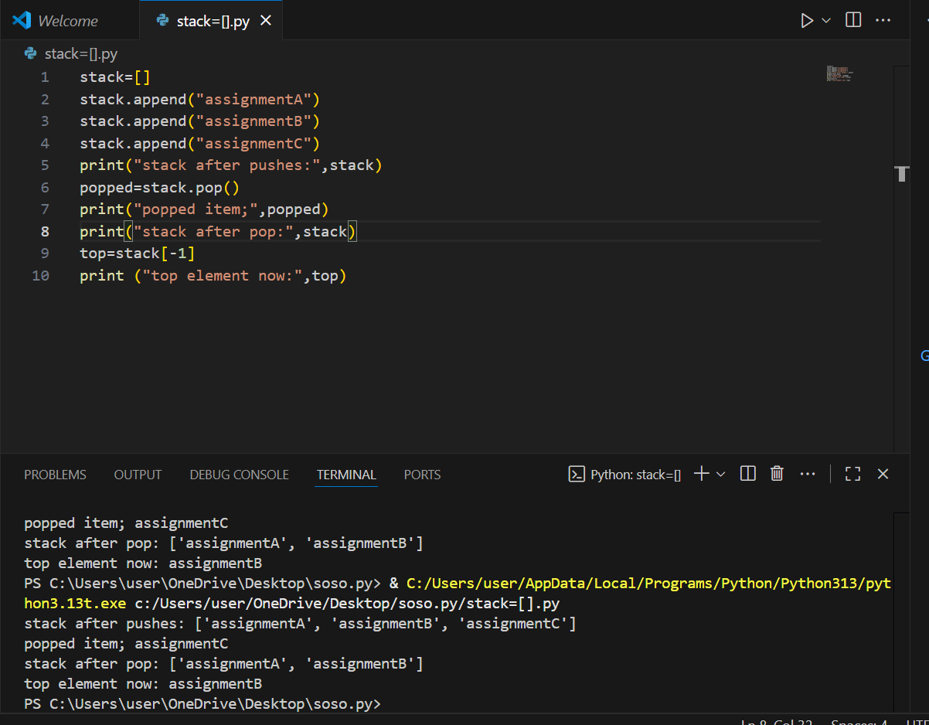

Qn2;pratical(Rwanda ):in irembo ,push[“step1”,”step2”,step3”]undo2.which remain “step1” remained afer undoing.

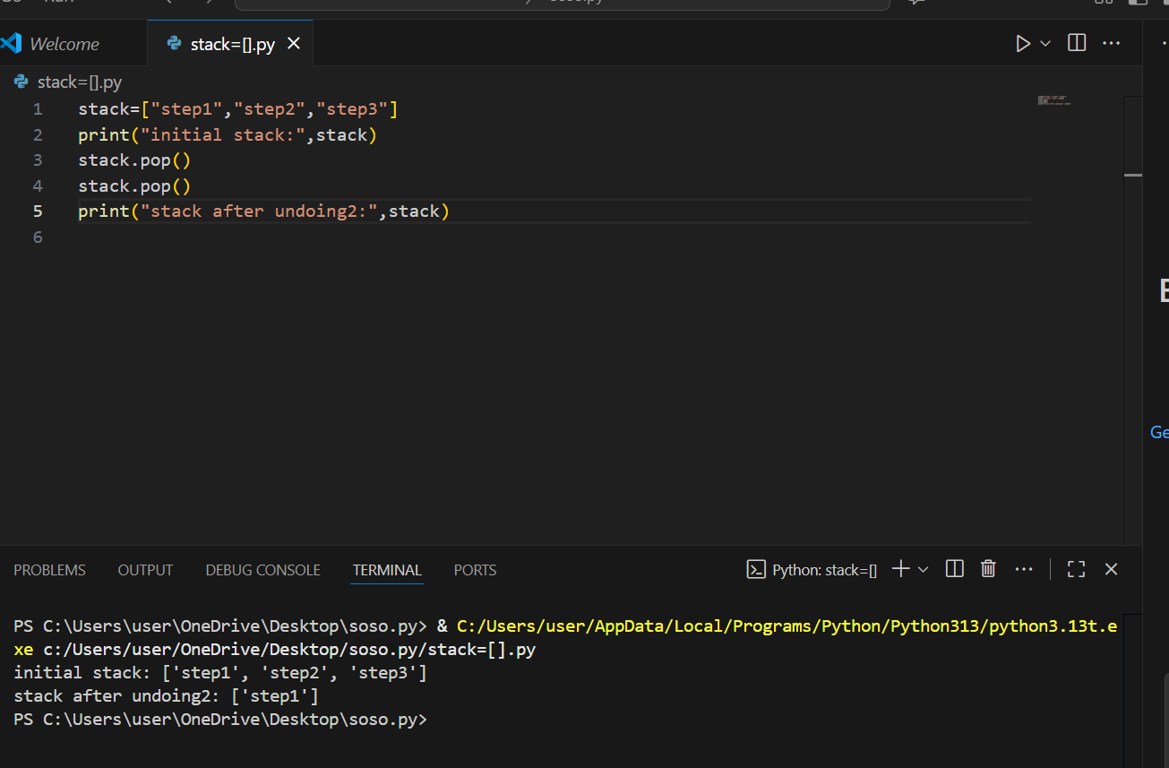

Qn3; challenge: push [ “1”,”2”,”3”,”4”,],pop2,push”5”. Which is top it is “5”element

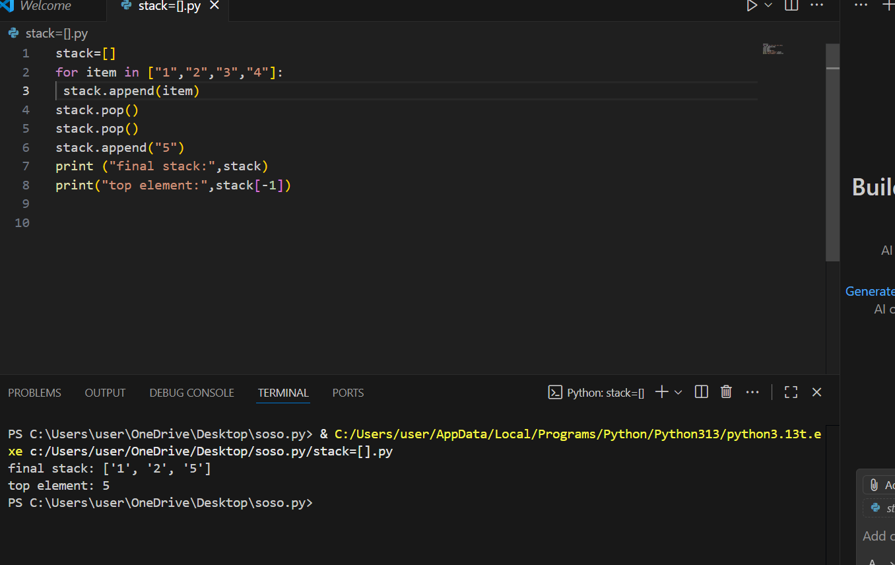

Reflection; why stack naturally models undo?

* Stack follow LIFO (last in first out. when performing task ,the last action you take is the first one you usually want to undo. For example in typing the last character typed in first to be removed when you press back space. This makes stacks a natural fit for undo\undo operations

**Queue questions**

Qn1;pratical (RWANDA): at nyabugogo ,6 buses queue .after 3 depart who is front is 4bus.

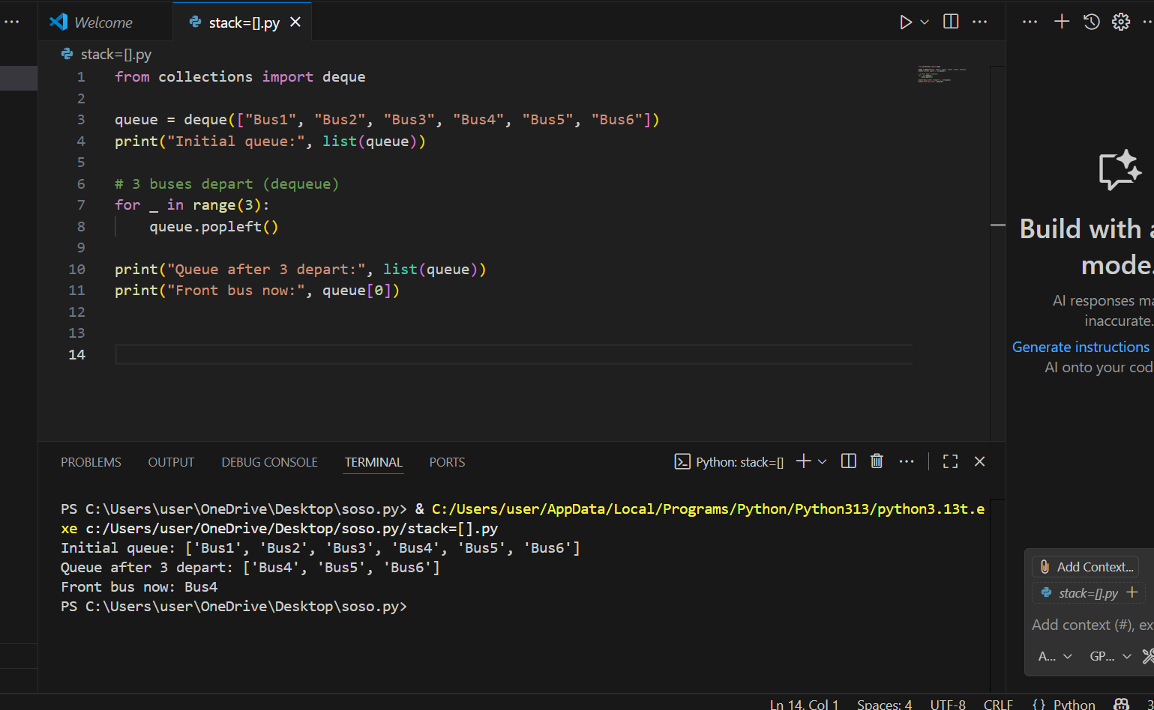

Qn2; practical (Rwanda);at airtel ,9client queue who is last?the last 9client

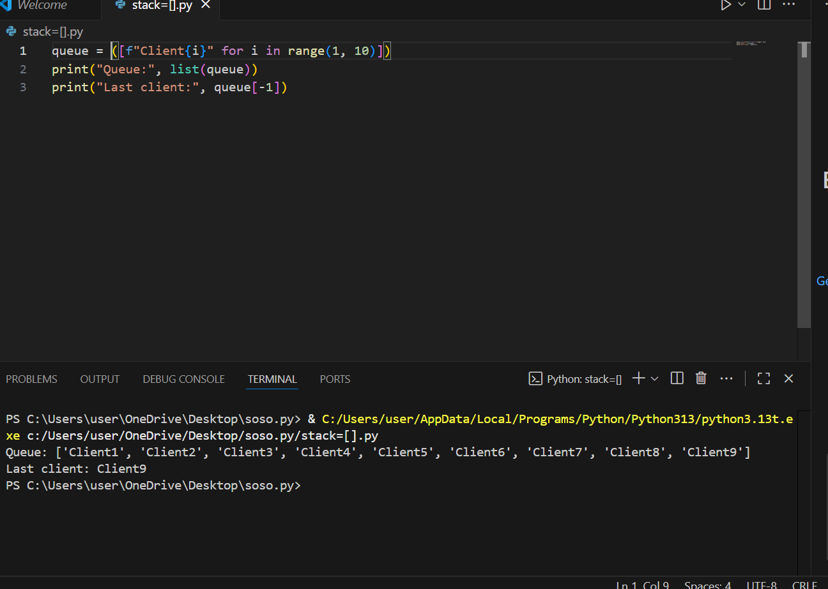

### ****Challenge: Queue vs stack for ticket sales. Which works?****

1. ticket sales must be **fair** → first person in line should be served at the first.in queue
2. stack would serve the **last person** who arrived → unfair .(stack)
3. Queue should serve the **first person who arrived** → fair.

* **queue:** **Queue works better** for ticket sales because it ensures **FIFO fairness**.

**qn4. Reflection: Why FIFO ensures fairness at events?**

FIFO means **first in, first out**. People who arrive earlier get served earlier, preventing latecomers from skipping ahead. This fairness builds trust, avoids conflicts, and ensures order in public services like ticket sales, banking.

* That completes **Project 116** with code, outputs, algorithms, and reflection.